Taxonomy, Classification, and Dichotomous Keys
1. 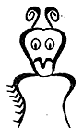 | 2. 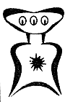 | 3. 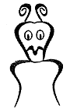 | 4. 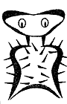 | 5. 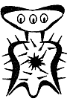
6. 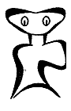 | 7. 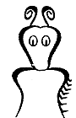 | 8. 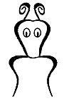 | 9. 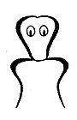 | 10. 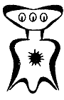
11. 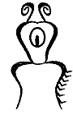 | 12. 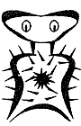 | 13. 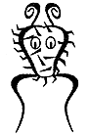 | 14. 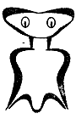 | 15. 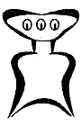
16. 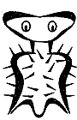 | 17. 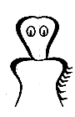 | 18. 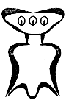 | 19. 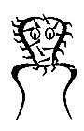 | 20. 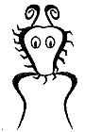

Help! Scientists have discovered quite a few new creatures on planet UOIT. They need your help to identify and classify them. Use the dichotomous key on the next 2 pages to identify these creatures. Once you have identified all of the creatures, cut and paste the creatures into the correct position in the dichotomous key chart.

A Key to New UOIT Creatures

- a. The creature has a large wide head………………………………….……………………………….go to 2
b. The creature has a small narrow head…………………………………………………………….go to 11

- a. It has 3 eyes……………………………………..……………………………………………………………….go to 3
b. It has 2 eyes……………………………………………….……………………………………………………..go to 7

- a. There is a star in the middle of its chest…………………………………………………………….go to 4
b. There is no star in the middle of its chest…………..……………………………………………..go to 6

- a. The creature has hair spikes………………………..………………………………..………Broadus hairus
b. The creature has no hair spikes…………………………………………………………………………go to 5

5. a. The bottom of the creature is arch-shaped…………………………………………..Broadus archus
b. The bottom of the creature is M-shaped……………………………..……………..Broadus emmus

6. a. The creature has an arch-shaped bottom……………………………………………Broadus plainus
b. The creature has an M-shaped bottom………………………………………….…….Broadus tritops

7. a. The creature has hairy spikes…………………………………………………………………………….go to 8
b. The creature has no spikes………………………………………………………………….…………..go to 10

8. a. There is a star in the middle of its body………………………………………...Broadus hairystarus
b. There is no star in the middle of its body………………………………………….……………….go to 9

9. a. The creature has an arch shaped bottom………………………………….…Broadus hairyemmus
b. The creature has an M-shaped bottom………………………………………………..Broadus kiferus

10. a. The body is symmetrical…………………………………………………………………..……Broadus walter
b. The body is not symmetrical……………………………….……….……………………Broadus anderson

11. a. The creature has no antennae……………………………………………………………………….…go to 12
b. The creature has antennae………………………………….……….………………………..…………go to 14

12. a. There are spikes on the face……………………………...........................……….Narrowus wolfus
b. There are no spikes on the face………………………………………………….…………………….go to 13

13. a. The creature has no spikes anywhere…………………………………………….…Narrowus blankus
b. There are spikes on the right leg……………………………………….…..…..Narrowus starboardus

14. a. The creature has 2 eyes………………………………………………………………………………..…..go to 15
b. The creature has 1 eye……………………………………………………………………….Narrowus cyclops
15. a. The creature has a mouth…………………………………………………………………………….…go to 16
b. The creature has no mouth………………………………………………………………………….….go to 17

16. a. There are spikes on the left leg…………………………………………………………...Narrowus portus
b. There are no spikes at all………………………………………………………………..…..Narrowus plainus

17. a. The creature has spikes………………………………………………………………………………….…go to 18
b. The creature has no spikes…………………………………………………………..….Narrowus georginia

18. a. There are spikes on the head…………………………………………………………………………….go to 19
b. There are spikes on the right leg……………………………………………………Narrowus montanian

19. a. There are spikes covering the face……………………………………………….……Narrowus beardus
b. There are spikes only on the outside edge of the head………………….…….Narrowus fuzzus

References:

http://www.biologycorner.com/worksheets/pamishan.html

Dichotomous Key Chart
Broadus hairus | Broadus archus | Broadus emmus | Broadus plainus | Broadus tritops
Broadus hairystarus | Broadus hairyemmus | Broadus kiferus | Broadus walter | Broadus anderson
Narrowus wolfus | Narrowus blankus | Narrowus  starboardus | Narrowus cyclops | Narrowus  portus
Narrowus plainus | Narrowus georginia | Narrowus  montanian | Narrowus  Beardus | Narrowus fuzzus

