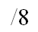
Name: _______________
Mitosis and Meiosis Quiz

- Which of the following is a phase of mitosis?
- Cytokinesis
- Interphase
- Prophase
- S phase

- If the parent cell starts out with 24 chromosomes and undergoes mitosis, then how many will the daughter cells have?
- 48
- 12
- 5
- 24

- What is the last phase of mitosis?
- Telophase
- Interphase
- Metaphase
- Prophase

- Put the following stages in the cell cycle in order.

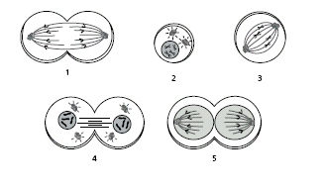
- 5,3,1,2,4
- 3,1,4,2,5
- 4,1,2,5,3
- 2,3,1,5,4

- In meiosis, if the parent cells have 40 chromosomes, then how many will the daughter cells have?
- 40
- 10
- 20
- 18
- Meiosis produces which of the following?
- Plant cells
- Animal cells
- Sex cells
- Skin cells

- Identify this phase of mitosis.
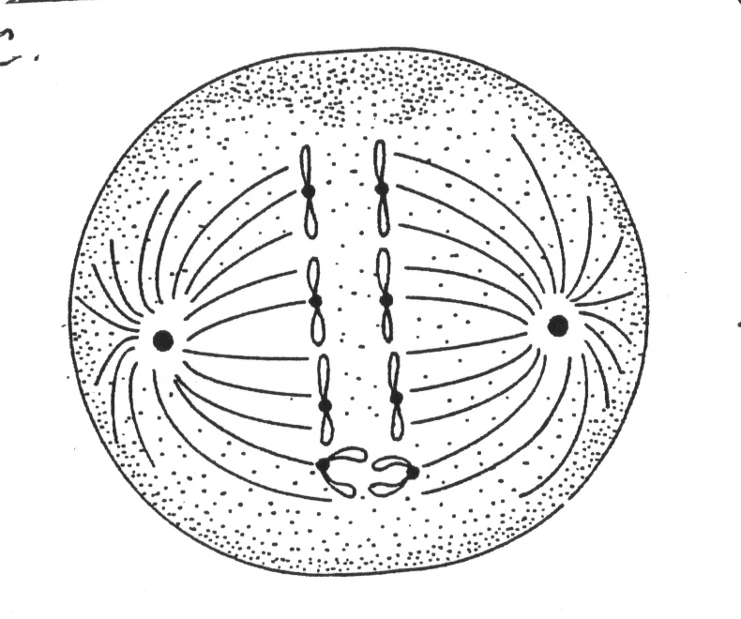
- Prophase
- Metaphase
- Anaphase
- Telophase

- Identify this phase of meiosis.
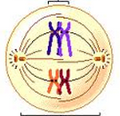
- Prophase 1
- Metaphase 1
- Metaphase 2
- Prophase 2

